READ CLOCKS
KS1 – 2002 Paper
1.
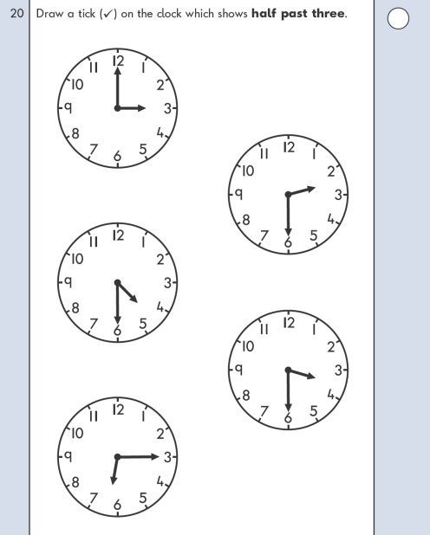
KS1 – 2004 Paper 1
2.

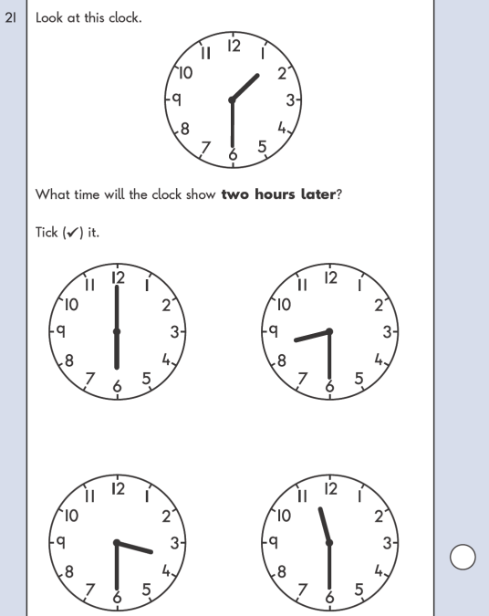
KS1 – 2005 Paper 1
3.

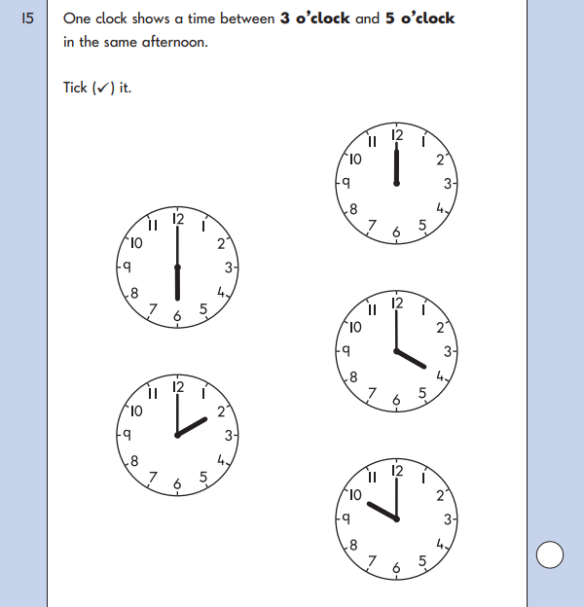

KS1 – 2016 Paper - Reasoning
4.
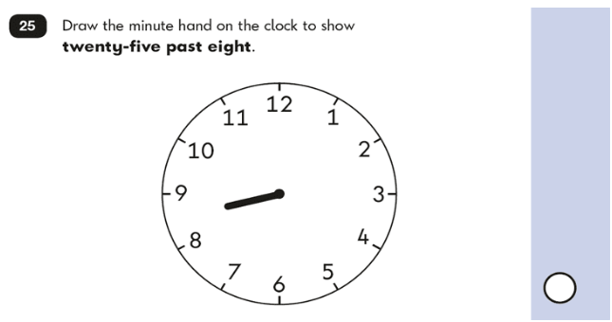
KS1 – 2016 Paper – Reasoning (Second)
5.
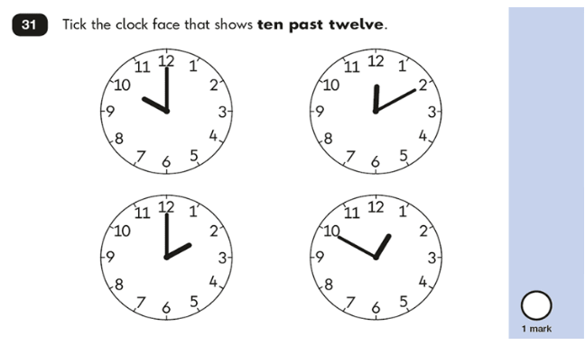

KS1 – 2017 Paper – Reasoning
6.
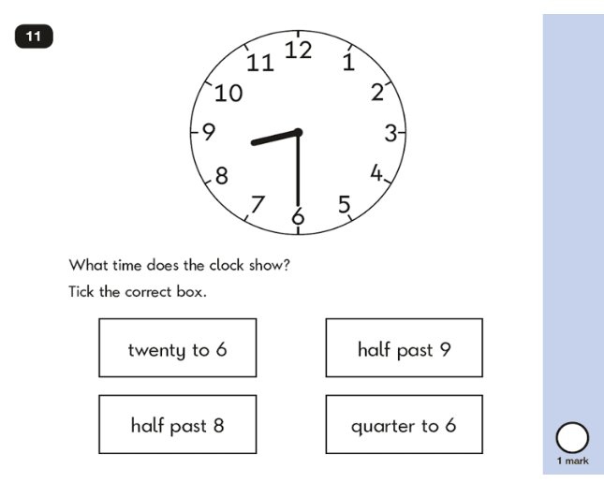
KS1 – 2019 Paper – Reasoning
7.
